

MGUS Service Pathway

Communication for gp surgeries

2025

Table of Contents

1. New Referrals 2

1.1 Key points: 2

2. Existing Patients Monitored by the GP Surgery 4

Information to Include in the Referral Email 4

3. Timeline 4

# New Referrals

Follow the flowchart below.

## 1.1 Key points:

* All **new MGUS diagnoses** must go through the **Haematology Department**. We do **not** accept new referrals directly.
* All results that are MGUS but otherwise normal will be recorded and coded in the **MGUS Ardens template** on S1 in the patient record by the MGUS Service.
* The MGUS service will add the read code **XabSv Monoclonal paraprotein threshold for referral** to patient consultation notes.
* If blood results are **abnormal but not related to MGUS**, we will send a letter to the patient and their GP with advice on next steps.
* If the patient progresses to Myeloma, the MGUS service will make a direct referral to Haematology. A letter will be sent to the patient and their GP with advice on the next steps.

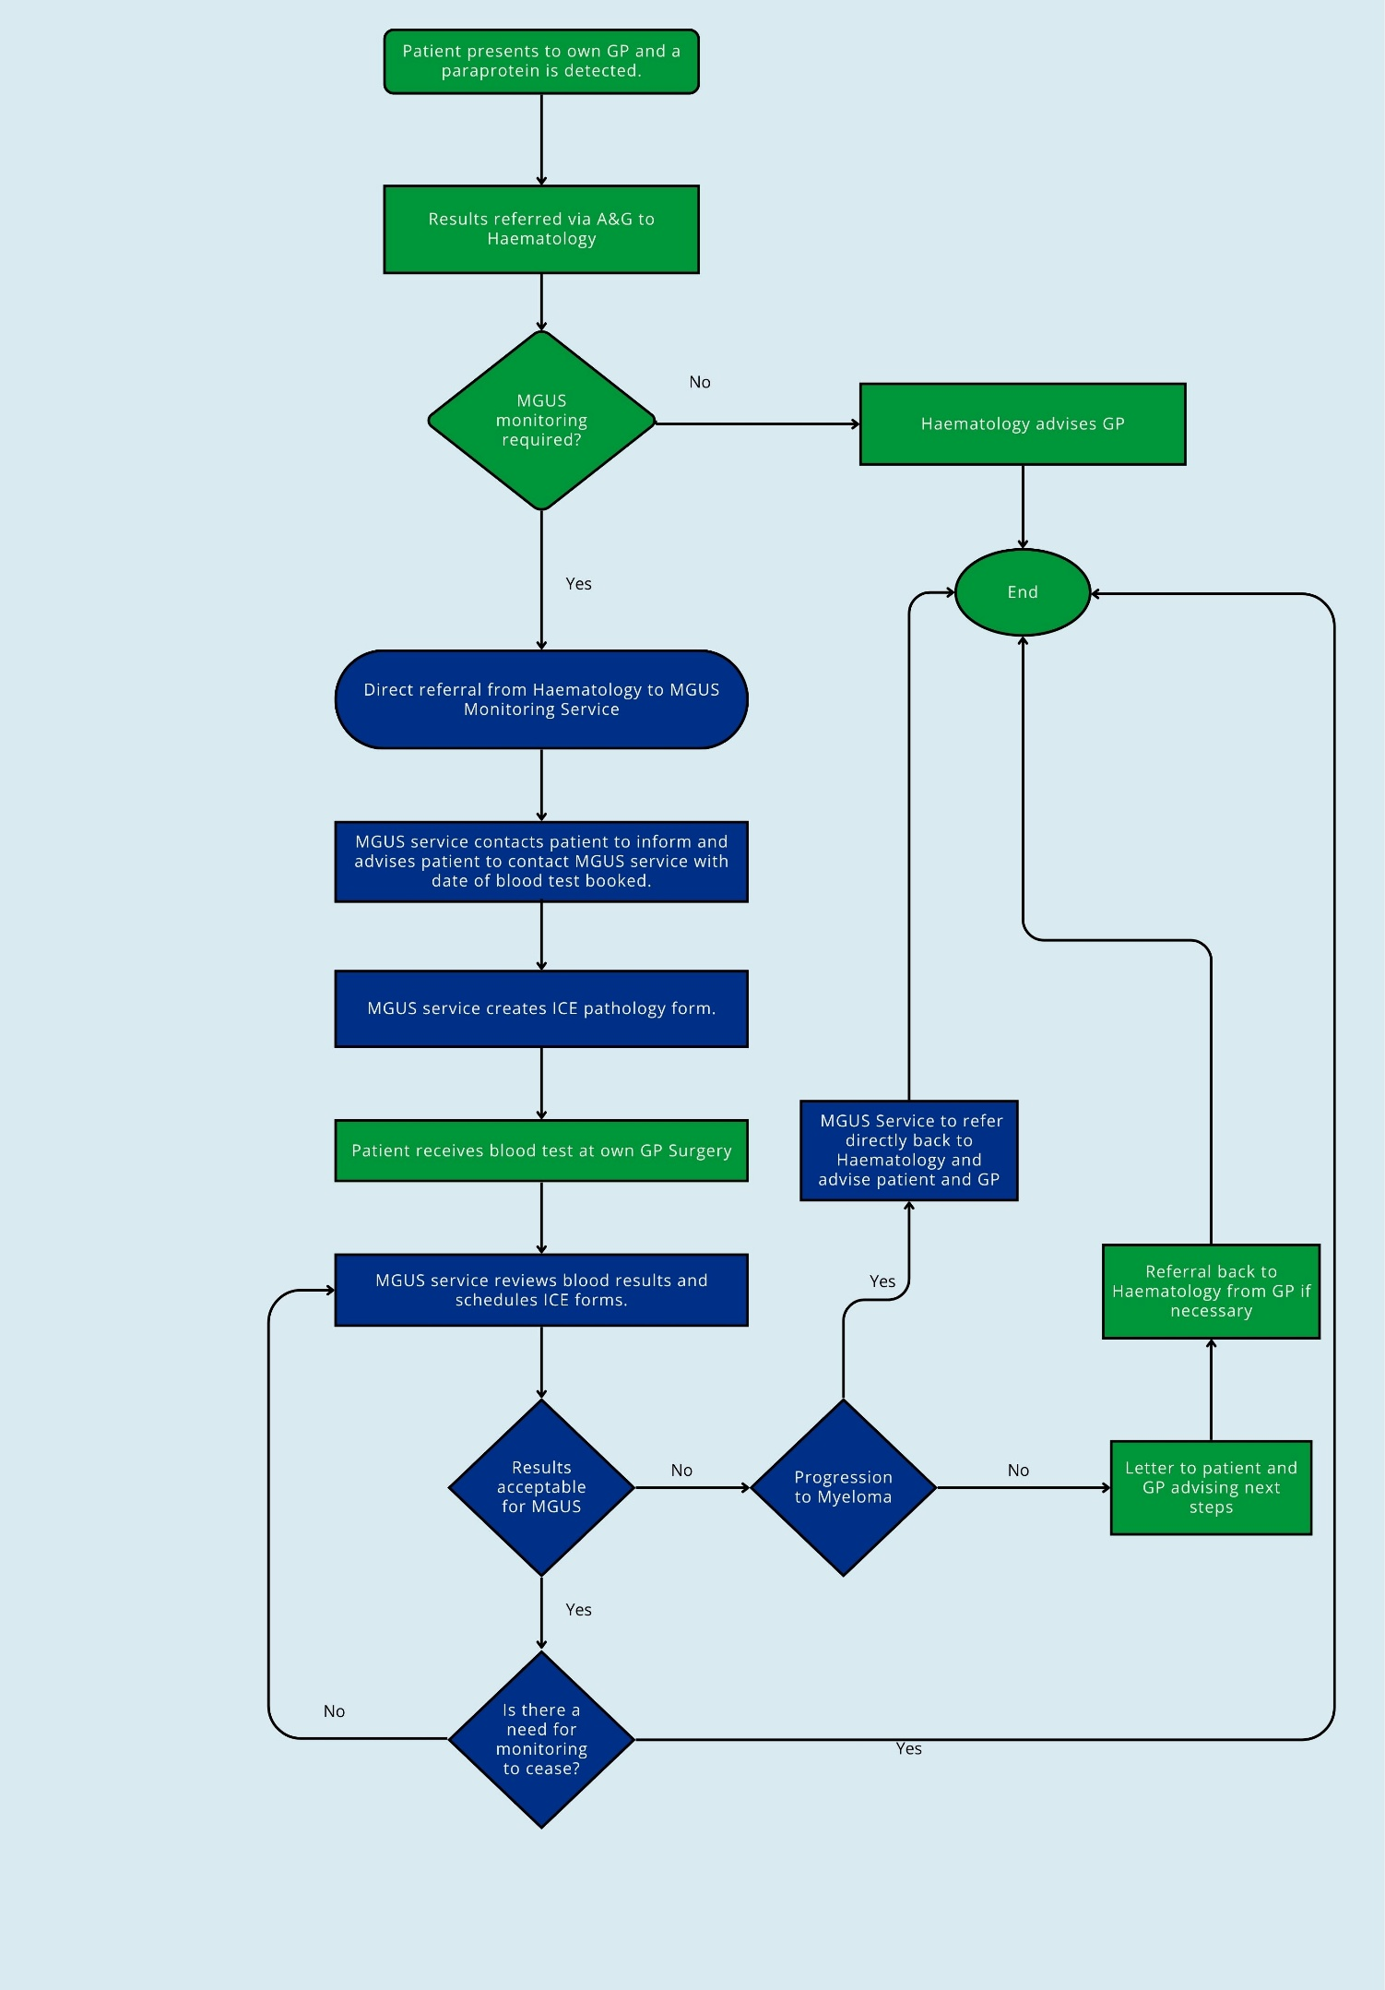

# Existing Patients Monitored by the GP Surgery

We will accept referrals via the **MGUS inbox (MGUSreferrals@dorsetgp.nhs.uk)** if the patient meets the following criteria:

* Confirmed diagnosis of MGUS.
* Not included in the backlog lists provided by Haematology.

*A list of patients by surgery already referred by Haematology will be provided.*

## Information to Include in the Referral Email

* Patient NHS number
* Date of MGUS diagnosis
* Monitoring interval (6 or 12 months)
* Date of next blood test due

# Timeline

Please note this is an approximate timeline and we will circulate further communications to confirm.

|  |  |
| --- | --- |
| Key dates | Actions |
| 1–14 October 2025 | Clear backlog list for DCH |
| 15th October- 24th October | Transfer currently monitored patients through **DCH**  Circulate current MGUS patient lists to each **GP surgery (DCH area)** |
| 27th October | MGUS inbox opens for patients monitored by GP surgeries in the **DCH area** |
| 27th October- 7th November | Clear backlog list for **UHD** |
| 10th November- 14th November | Transfer currently monitored patients through **UHD**  Circulate current MGUS patient lists to each **GP surgery (UHD area)** |
| 17th November | MGUS inbox opens for patients monitored by GP surgeries in the **UHD area** |